Student guide: Building models to   
understand and mitigate brain injury

**Your mission**

As a **biomedical engineer**, you have been invited to participate in an important brain injury prevention program. Current research reveals new insight on how head collisions impact the brain and its functions. Many of these collisions happen during sports-related activities. As a result, athletic organizations and equipment companies are interested in better protecting athletes. These organizations have asked you and your team of engineers to assist in designing protective head gear.

First, analyze athletic concussion data and conduct research to better understand the functions associated with different brain regions. Then construct a model of the human brain, equip it with impact sensors and use it to develop and test designs for protective head gear to be used in athletic activities.

Let’s get started!

**Prior knowledge and vocabulary**

**Complete questions 1-4 individually then discuss with your team.**

1. What functions does the brain perform for the human body?
2. List three activities that could put you at risk for a brain injury.
3. Describe two ways to prevent brain injury.
4. Are there any questions you still have about the brain? How can you find these answers?

**Define the key words:**

* Concussion
* Traumatic Brain Injury (TBI)
* Biomedical Engineer
* Mitigate

**Data analysis: Concussions by sport**

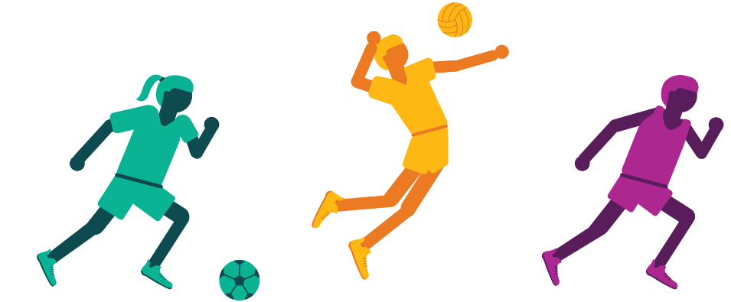

Head collisions during sports are just one of many ways people sustain concussions. Falls and car accidents can also cause brain injuries. Check out the [Concussions by sport infographic in the Excel workbook](https://aka.ms/brain-impact-workbook) that shows the number of occurrences of concussions across sports.

**As you analyze concussion data, consider these questions:**

* 1. What information from the Excel workbook data surprises you?
  2. Of the activities presented in the workbook, which ones do you participate in?
  3. Based on the data, do you think these activities present a significant risk for a TBI?

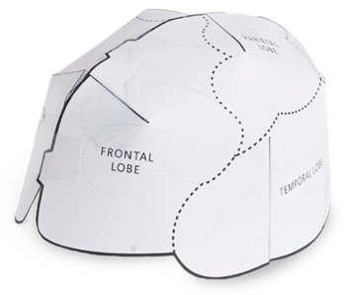**Modeling: Make a brain hat**

What do you already know about the regions of the brain? Let’s find out more by making a paper brain hat. The brain hat is a tool you can use to learn the brain regions and what they do.

Use these [instructions and template to create the brain hat](https://aka.ms/brain-hat-template/en).

Complete the table below by referring to the [Brain regions sheet in the Excel workbook](https://aka.ms/brain-impact-workbook) to investigate behaviors and emotions controlled by different regions of the brain.

|  |  |  |
| --- | --- | --- |
| **Brain Region** | **Emotional Functions** | **Behavioral Functions** |
| Frontal Lobe |  |  |
| Parietal Lobe |  |  |
| Temporal Lobe |  |  |
| Occipital Lobe |  |  |

**As you learn about brain regions, consider this question:**

After a head injury, a person could have impaired ability to taste. Which part of the brain may have been damaged? How do you know?

**Simulation: Build a brain model with impact sensors**

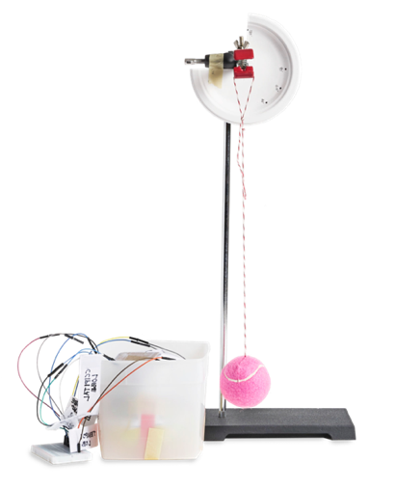To better understand the effects of a head injury, you will build a model of the brain to simulate a concussion. The brain will be represented by a balloon.

Pressure sensors attached to the brain hat will measure the amount of pressure the brain experiences when hit by a pendulum. The hat will then be placed on the balloon and transferred to a container.

This process will mimic the impact the brain could experience in an activity, such as soccer or swimming. [Build the brain model and Brain Impact Simulator using these instructions](https://aka.ms/brain-impact-instructions/en).

**As you build, consider these questions:**

* 1. Why is it important to use a balloon filled with water beads to simulate the brain? Why is this better than a balloon just filled with air? What does the container represent?
  2. Which characteristics of the pressure sensors make them suitable for measuring the impact of a collision on the model brain? Why are they located on different brain regions?

**Data visualization: Analyze collision impact in Excel**

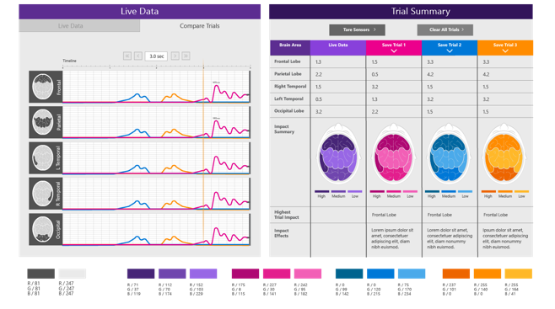You can now visualize the magnitude of the pendulum’s impact using [Excel](https://aka.ms/brain-impact-workbook).

For the purposes of this simulation, the impact is measured in Brain Impact Units (BIUs). BIUs are a unit of measure developed for this model that can be used to compare the magnitude of different impacts. You can change the amount of impact by changing the height of the pendulum. You will then test different protective materials to mitigate head injury.

**Use the** [**Impact simulator data sheet in the Excel workbook**](https://aka.ms/brain-impact-workbook)**, and your Brain Impact Simulator to answer the following questions:**

* 1. How does the height of the pendulum change the BIUs acting on the brain?
  2. When the pendulum hits one part of the brain, are the other lobes affected? What evidence do you have to support your answer?
  3. Use the materials provided by your teacher to try to reduce the force of collision impact associated with your brain model and pendulum.
  4. Were you successful in reducing the collision impact force? Use data to justify your explanation.

*As you visualize each collision impact, consider the fact that brain research is an evolving scientific field. Scientists are making new discoveries every day about how the brain works. Information about the functioning of the brain and the effect of injury on brain functions as stated in this lesson and workbook are based on the referenced sources. As scientists make new discoveries, our knowledge of the brain, its function and the effect of injury will also change.*

**Engineering design: Protective head gear**

Concussion research is an evolving scientific field. What we do know is that concussions can have a long-term impact on thinking, sensing, talking and feeling. The good news is that you can mitigate the impact of a concussion by wearing protective head gear.

Design a solution to lessen the magnitude of the impact when the pendulum hits your brain model. Your protective head gear should lessen the severity of a concussion impact to the greatest extent possible.

Use the [Engineering design challenge](https://aka.ms/brain-design-challenge/en) document to guide you. Along the way, you will engage in a design process that real engineers use to create solutions for a wide variety of problems. The [Impact simulator data sheet in the Excel workbook](https://aka.ms/brain-impact-workbook) is designed to help you test your prototypes and determine the maximum force sustained by each lobe of your brain model. Good luck engineers!

**The Think Taylor Pledge**

Taylor Twellman, a former U.S. Men’s National Team player and Major League Soccer MVP with the New England Revolution, is ESPN’s lead analyst for Major League Soccer, U.S. Men’s National Team matches, and other international events.   
   
 Twellman played eight professional seasons for the Revolution and was one of Major League Soccer’s most prolific forwards before his career was prematurely cut short after suffering from multiple concussions.  He scored 101 goals in 174 matches for the team, thus becoming the fastest player in MLS history to score 100 goals and the Revolution’s all-time leading goal scorer.    
   
 For over seven years, Taylor has suffered from the effects and symptoms of post-concussion syndrome (“PCS”.) Taylor realized, his career-ending injury was a life-changing event and was inspired to make a difference in the world of concussions.   
   
 He founded [ThinkTaylor](http://www.thinktaylor.org/), a foundation that is driven and dedicated to changing the culture in the world of concussions. ThinkTaylor’s positive message emphasizing awareness, rehabilitation and education is putting the health of kids first and creating a positive social change and in return a safer, healthier and smarter environment.

Now that you have modeled what happens when the brain collides with the skull, we encourage you to take the [Think Taylor #TTPledge](http://www.thinktaylor.org/ttpledge/), a commitment for players, coaches, parents and teachers to be educated about the signs and symptoms of concussion, to be honest in reporting concussions and support those suffering from concussion. Please take a moment to learn more about the [signs and symptoms of concussions](https://www.cdc.gov/headsup/pdfs/youthsports/parent_athlete_info_sheet-a.pdf).

**Resources**

Use these resources to explore more information on brain function, injury and protection. We used some of these same resources to develop this activity.

[Brain Injury Safety Tips and Prevention, Center for Disease Control and Prevention](https://www.cdc.gov/headsup/basics/concussion_prevention.html)

[Playground Injuries: Fact Sheet, Center for Disease Control and Prevention](https://www.cdc.gov/HomeandRecreationalSafety/Playground-Injuries/playgroundinjuries-factsheet.htm)

[The Evolution of the Football Helmet, Smithsonian](https://www.smithsonianmag.com/arts-culture/leatherhead-to-radio-head-the-evolution-of-the-football-helmet-56585562/) Magazine

[Research on Concussions: Keeping Your Head in the Game, US Department of Health and Services](https://www.nichd.nih.gov/newsroom/resources/spotlight/020612-concussions)

[Anatomy of the Brain, Mayfield Brain and Spine](https://mayfieldclinic.com/pe-anatbrain.htm)

[Cognitive Skills of the Brain, Brain Injury Alliance of Utah](https://biau.org/about-brain-injuries/cognitive-skills-of-the-brain/)

[Overview of Cerebral Function, Merck Manuals](https://www.merckmanuals.com/professional/neurologic-disorders/function-and-dysfunction-of-the-cerebral-lobes/overview-of-cerebral-function)

**Related activities**

Explore these related [Hacking STEM activities](https://aka.ms/hackingstem):

[Measure speed to understand forces and motion](https://www.microsoft.com/en-us/education/education-workshop/sensorized-track.aspx)

[Visit activity page](https://www.microsoft.com/en-us/education/education-workshop/activity-library.aspx)

**Credits**

This lesson was authored by Jenn Tullis, Katie Brown and Tim Robinett, teachers from the Davis School District in Utah. They developed the activity with Microsoft employees during the 2018 Microsoft OneWeek Hackathon.

The Brain Hat activity and template were inspired by Ellen McHenry’s [Brain Hemisphere Hat](https://na01.safelinks.protection.outlook.com/?url=http%3A%2F%2Fellenjmchenry.com%2Fbrain-hemisphere-hat%2F&data=04%7C01%7CBryce.Henthorn%40microsoft.com%7C7e036904e36f4eb35a4f08d6468ce947%7C72f988bf86f141af91ab2d7cd011db47%7C1%7C0%7C636773969188525648%7CUnknown%7CTWFpbGZsb3d8eyJWIjoiMC4wLjAwMDAiLCJQIjoiV2luMzIiLCJBTiI6Ik1haWwiLCJXVCI6Mn0%3D%7C-1&sdata=v2J6GMDLmTZR949RnyiVNzOkKgQ7oC2AUf2vGePUhbQ%3D&reserved=0).